XIAMEN UNIVERSITY
Exchange Program Fact Sheet 2025-2026

Office of International Cooperation and Exchange, Xiamen University
Xiamen University and the City
XMU  General  Information |  | General Information about the university can be found at the webpage below: http://en.xmu.edu.cn/
Campuses |  | Map of Siming Campus and Xiang’an Campus:  Map of XMU Siming Campus  Map of XMU Xiang'an Campus  Siming Campus is in Siming District, Xiamen, covering an area of 167 hectares. It houses Department of Chinese Language and Literature, School of History and Cultural Heritage, Department of Philosophy, School of Journalism and Communication, College of Foreign Languages and Cultures, College of Art, School of Film, School of Economics, The Wang Yanan Institute for Studies in Economics, School of Management, Institute of Financial& Accounting Studies, School of Law, Intellectual Property Research Institute of Xiamen University, Xiamen Academy of International Law, School of Public Affairs, School of Public Policy, School of Marxism, School of International Relations/Research School for Southeast Asian Studies, The Belt and Road Research Institute, Institute of Education, School of Sociology and Anthropology, School of Mathematical Sciences, College of Physical Science and Technology, College of Chemistry and Chemical Engineering, School of Informatics, College of Materials, School of Architecture and Civil Engineering, Pen-Tung Sah Institute of Micro-Nano Science and Technology.  Xiang’an campus is in Xiang’an District of Xiamen, 34 kilometers away from Siming Campus. It houses Chinese International Education College/Overseas Education College, School of Medicine, School of Pharmaceutical Sciences, School of Public Health, School of Aerospace Engineering, School of Life Sciences, College of Oceanography and Earth Sciences, Coastal and Ocean Management Institute, College of Environment and Ecology, and College of Energy, College of Electronic Science and Technology, and School of Information.
 | University Calendar | Fall Semester | Spring Semester
 |  | Early-September to mid-January | Late February to mid-June
Starting and ending dates of the semester, as well as dates for registration, will be included in the Admission Notice. Please see your Admission Letter and the academic calendar issued by the Academic Affairs Office (https://jwc.xmu.edu.cn/detail-v2.jsp?urltype=news.NewsContentUrl&wbtreeid=2601&wbnewsid=65251) for more details and possible changes.
Final examinations are held during the last two weeks of every semester.
Following the Spring Semester at Xiamen University (XMU) is a short Summer Semester of 3 weeks from mid-June to late July. Exchange students are not expected to participate in the Summer Semester and are allowed to leave officially for their holidays after the Spring Semester ends.
Academic schedules for Chinese language programs (including course and examination arrangements) will be provided by the Overseas Education College and available during course registration.
 | Holidays/Vacation | XMU students usually enjoy 9 weeks of summer vacation and 4 weeks of winter vacation.
 | Public Holidays (if any): | New Year’s Day (1 day off)  Tomb-sweeping Day (1 day off)  Labor Day (1 day off)  Dragon Boat Festival (1 day off)  Mid-Autumn Festival (1 day off)  National Day (7 days off)  For reference only. Details will be updated by Xiamen University as required.
Xiamen City |  | Information regarding Xiamen can be found at the webpage below:  Xiamen Overview-Admissions Office of Xiamen University (xmu.edu.cn)
Travel and Entertainment |  | Information regarding travel and entertainment in Xiamen can be found at the webpage below:  Attractions-Admissions Office of Xiamen University (xmu.edu.cn)

Course-related Information
Is course information available online? |  |  |  | As part of their application, it is vital for students to complete a Study Plan (https://admissions.xmu.edu.cn/system/_content/download.jsp?urltype=news.DownloadAttachUrl&owner=1732774152&wbfileid=14797914) that outlines the courses they intend to take. Please refer to Section V. Programs and Location of Campuses of the Application Guide for provisional course lists. Students can also consult the coordinator responsible for your section or the specific college for course information.
Is the course schedule/timetable available? |  |  |  | Yes. However, it won’t be available until the new semester begins. For the syllabus, new students are recommended to contact the college secretary during the first week of every semester (the week for registration and course selection)
What’s the procedure  for course selection? |  |  |  | Exchange students will receive their student IDs for course selection after admission. Online course registration will be open for several rounds, starting from before students arrive at XMU and complete arrival registration. Instructions on course selection will be sent by email from XMU’s coordinator and given during the Orientation at the beginning of each semester. Detailed information will be provided by XMU academic affairs offices (Academic Affairs Office and Graduate School) and relevant offices in charge of departments and colleges.  For courses provided by specific colleges, students are advised to complete course registration under the instruction of the host college’s secretary.
Are there any  restrictions on course selection? |  |  |  | Yes. In principle, undergraduate exchange students can only select undergraduate courses and postgraduate exchange students can only select postgraduate courses. Exchange students should get approval from both colleges for cross-college course selection. Only XMUM students can choose courses of Traditional Chinese Medicine from the School of Medicine. Students enrolled in Chinese as a Foreign Language programme will receive two different transcripts if they choose other courses outside the programme course system.
Are any courses conducted in English? |  |  |  | For undergraduate exchange students, English courses are primarily provided by School of Economics and School of Management.  For postgraduate exchange students, limited English courses are available in each college/school. Please consult the college secretary for more information.
Are there any intensive  language courses for  exchange students  prior to the exchange  program? |  |  |  | Yes. The University offers public Chinese language courses for degree students, which exchange students can also choose. These courses are available in both Siming and Xiang'an campus.
What is the minimum and maximum number of modules or credits for each semester/ year? |  |  |  | Usually, there is no requirement for the minimum or the maximum number of modules or credits undertaken on an exchange program — such requirements are normally made by students’ home institutions. However, exchange students usually complete around 15-25 credits per semester.  More policies regarding course selection will be advised during the orientation.
How do course credits correspond to class hours? |  |  |  | One credit is equivalent to 45-46 hours of academic work, comprising 15-16 hours of lectures and 30 hours of practice or self-study. 1 ECTS is roughly equivalent to 28 hours of work (as defined by the EU, ranging from 25-30 hours).
What are the requirements for in-class performance? |  |  |  | In XMU, full-time students (exchange students included) are required to have a complete attendance record (the minimum attendance rate is 70%) of the selected courses. Poor in-class performance and failure to complete assignments may result in students being unable to sit their final exams. Failure to meet relevant requirements will result in the loss of the credits of the course.
How to obtain transcripts? |  |  |  | Students are expected to download the transcript via the XMU student portal (https://i.xmu.edu.cn/).  If you find your account has been deactivated and is therefore unable to apply for an electronic transcript, it is because accounts are temporarily disabled during the transition from student to alumni status. Access can be restored by re-authenticating through the Digital Campus Card system.  The Digital Campus Card is linked to the “UnionPay” (云闪付) app. Please open the UnionPay app and search for the “XMU Digital Campus Card (厦大数字校园卡)” mini program. You probably have used this program during your studies.  If you have never used the UnionPay app and the XMU Digital Campus Card mini program, please contact the staff at the XMU Office of International Affairs via email. They will assist you with downloading the transcript.
 | Admission, Accommodation and Fees
 | Admission and Accommodation | - Students who pass the review of application materials will receive an Admission Letter and visa-related application materials in electronic form.  - The XMU Student Accommodation Service will assist students with on-campus accommodations, however, on-campus housing is not guaranteed.
 | Are there photos and information about the accommodation? | International student apartments are available on Siming and Xiang’an campuses. The apartments on Siming campus each have a twin-room, while the apartments on Xiang’an campus are in suites, with each suite consisting of four twin-rooms. Each room is equipped with beds (mattresses and bedding are not provided), desks and chairs, wardrobes, an air conditioner, a water heater, a bathroom (suites have a different bathroom arrangement), and Internet access (paid by students). Communal self-service washers and dryers and other equipment are available.  Apartments on Siming Campus  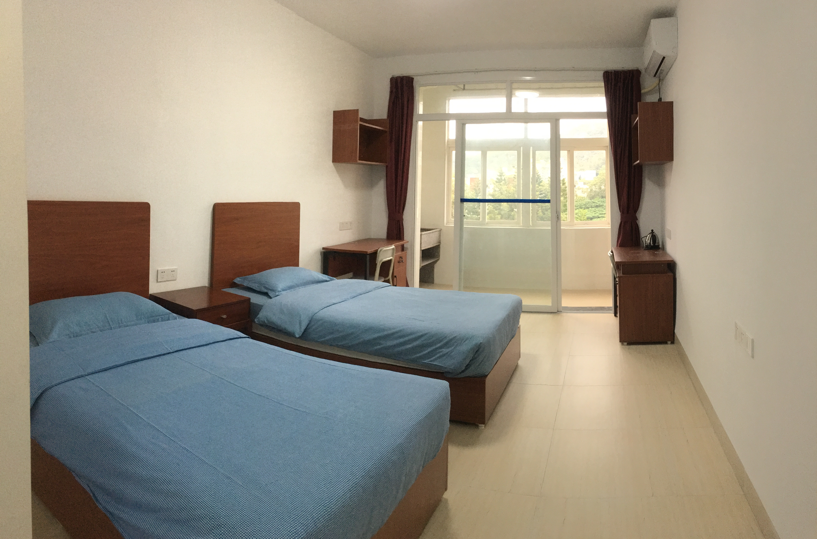  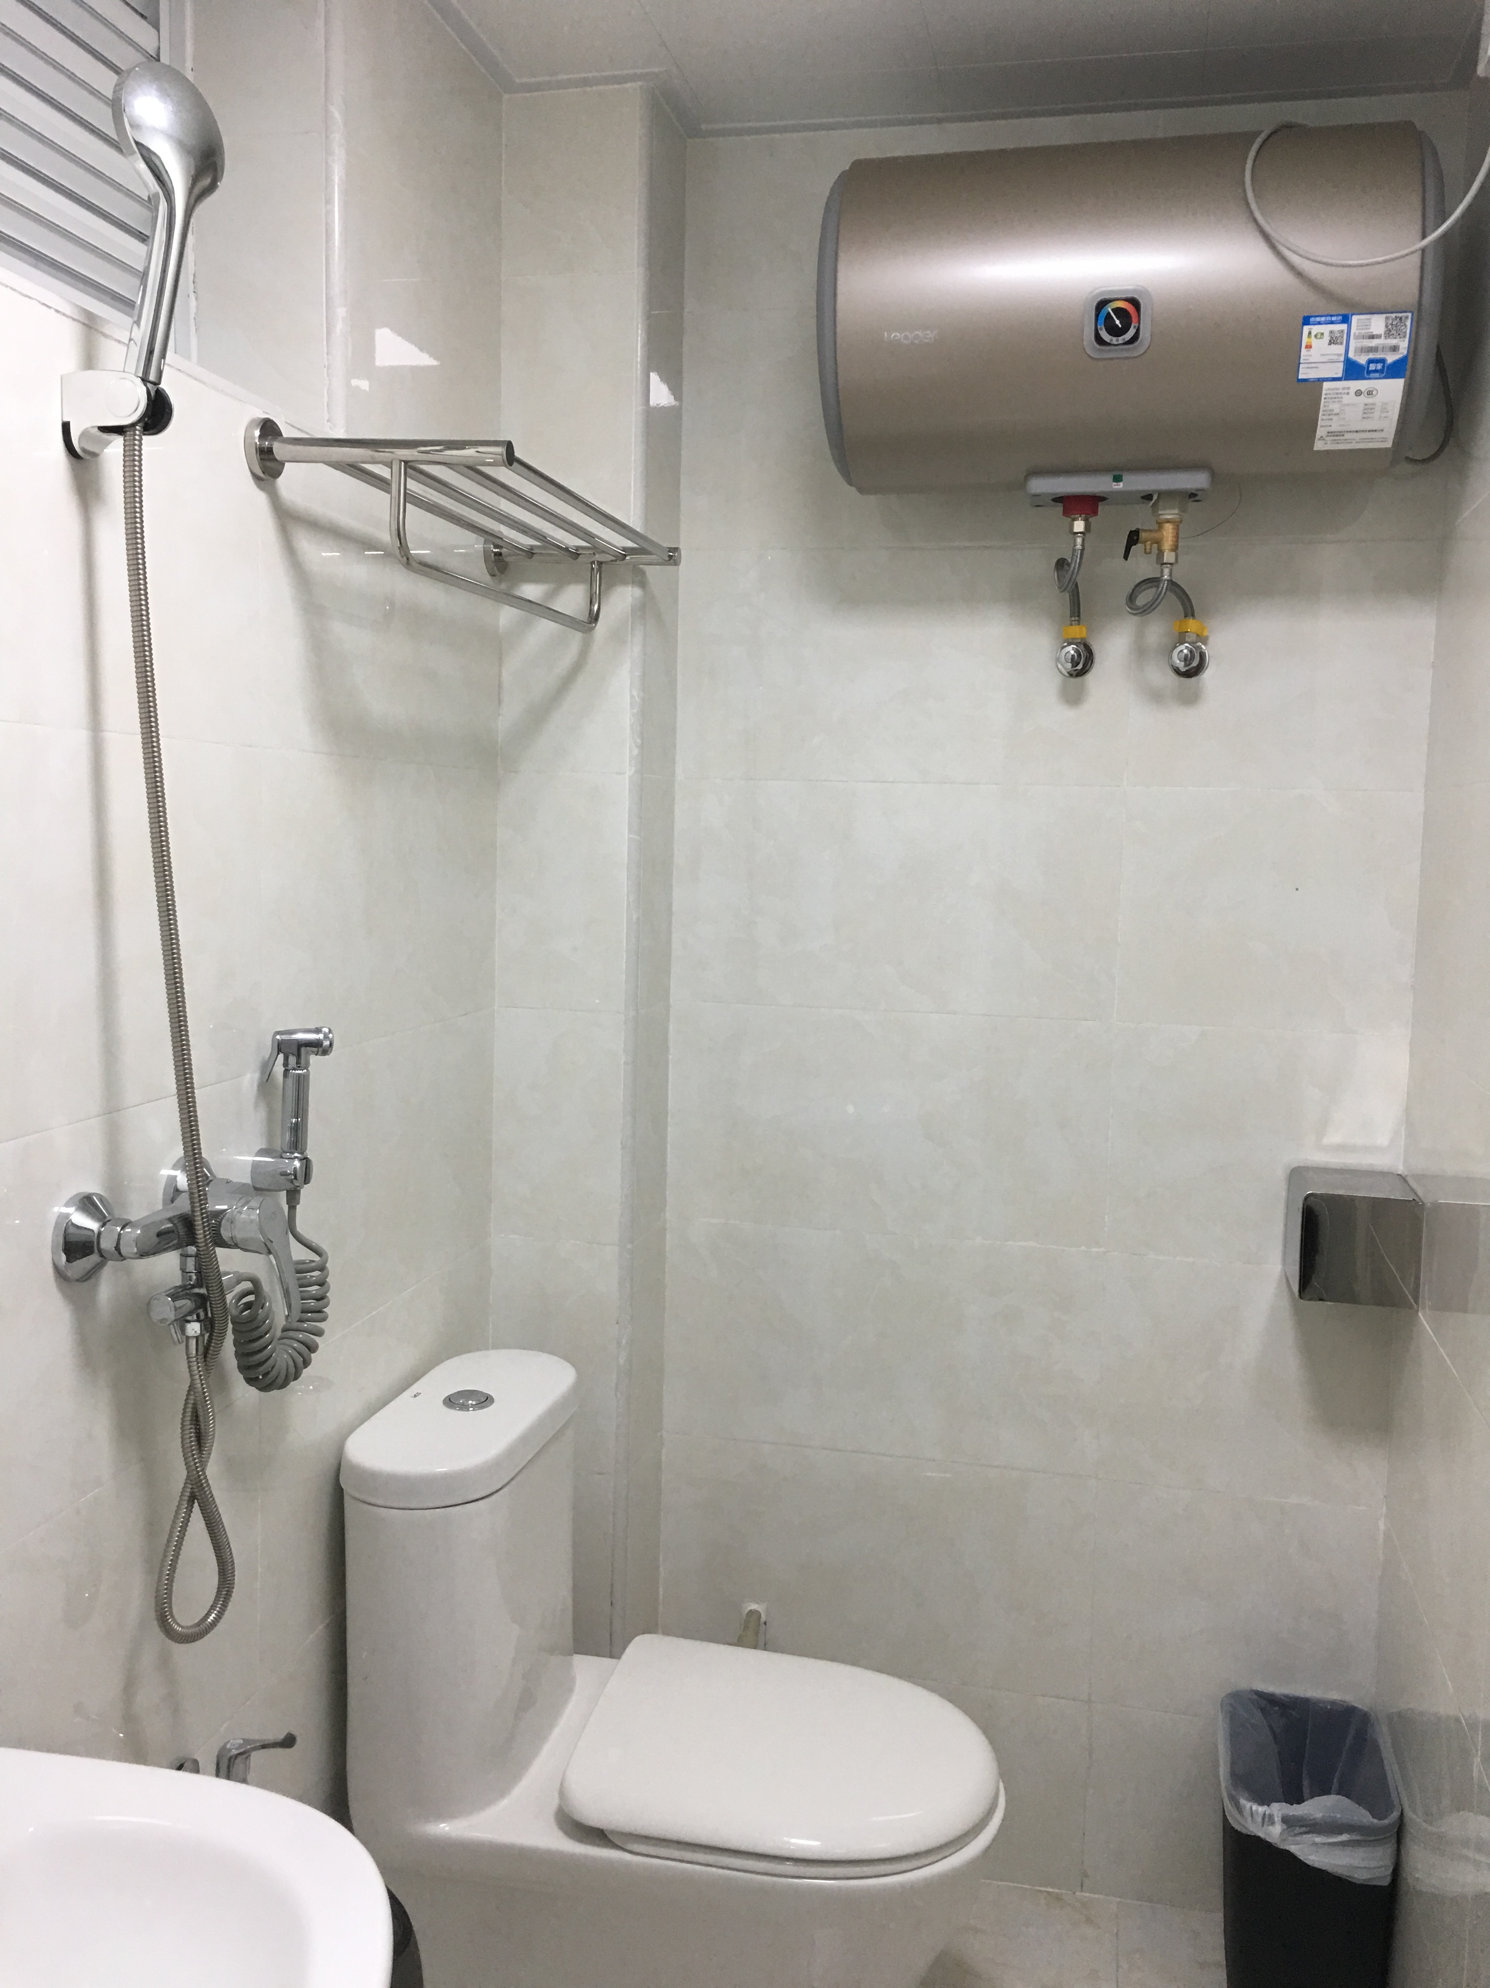  Apartments on Xiang’an Campus  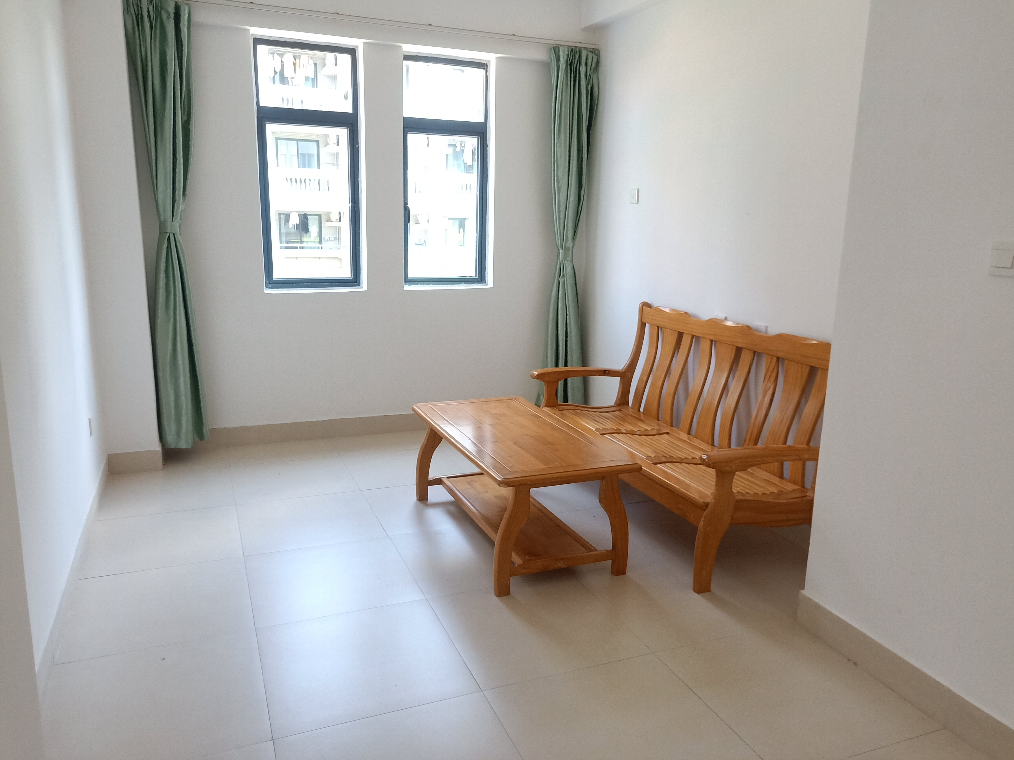  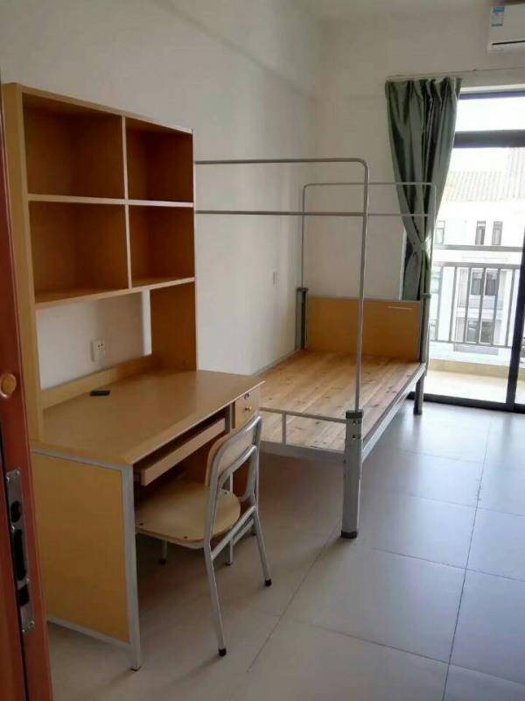
 | Fees | - Tuition fee: subject to bilateral exchange agreements.  2. On-campus accommodation fee: subject to bilateral exchange agreements. Around 35-65 RMB/day (Siming Campus); 1,600-4,000 RMB/year (Xiang’an Campus) if needed.  Students who live on campus are also required to pay the security deposit, and water and electricity fees in accordance with the University's regulations (around RMB 200/month, actual expenses vary across individuals). Please refer to the latest notice for the charging methods and standards.  - Course materials: 400-700 RMB/academic year  4. Meals: Around RMB 1000-1500/month.  5. Insurance: Exchange students should purchase medical insurance to cover their exchange period before landing and provide the insurance receipt on registration. We recommend the students to purchase the insurance detailed here: https://mp.weixin.qq.com/s/dUndVa5JFLuGHdmD7BD3zQ  Other expenses for study in China, such as international travel expenses and living expenses, should be borne by the exchange students themselves.
 | Visa, Entry-permit and Insurance
 |  |  | International exchange students are advised to apply for an X1/X2 Visa (also
 |  |  | called a Student Visa) with the Admission Notice and Letter for Visa
 | Visa |  | application (JW202 Form) issued by XMU at the local Chinese Embassy in
 |  |  | their home country. Please contact the Embassy for application procedures
 |  |  | and requirements.
 |  |  | Upon arrival, exchange students are advised to visit the Student Affairs Hall (Counter 5, 1st Floor, Jiageng 3 Building, osao@xmu.edu.cn) for visa-related inquiries.
 | Are exchange students  allowed to work? |  | On campus: |  |  | Off campus:
 |  |  | Not allowed |  |  | Not allowed
 | Are exchange students required to purchase a compulsory medical insurance plan? |  | Exchange students from abroad are required to purchase insurance that can cover their stay at Xiamen University before their arrival at XMU.  Proof of valid insurance (in Chinese or English) should be presented upon registration. Registration will NOT be processed without valid insurance proof.
 | Contact
 | Name of University |  |  |  | Xiamen University (XMU)
 | Address |  |  |  | Office of International Cooperation and Exchange 8th Floor, Song’en Bldg, Xiamen University,  No. 422, South Siming Road, Xiamen, Fujian, P. R. China  Zip code: 361005
 | Online Application and Admission |  |  |  | 1. Partner institutions from the U.K.  Coordinator: Jon Liu  Tel: 0086-(0)592-2183811 E-mail: liujinlong@xmu.edu.cn  2. Partner institutions from the Americas  Coordinator: Karen Chen  Tel: 0086-(0)592-2189356 E-mail: xy.chen@xmu.edu.cn  3. Partner institutions from Europe (except The U.K.), Oceania and Africa  Coordinator: Stephanie Li  Tel: 0086-(0)592-2188373 E-mail: lms@xmu.edu.cn  4. Partner institutions from Asia  Coordinator: Yiyi Chen  Tel: 0086-(0)592-2183434 E-mail: chenyiyi@xmu.edu.cn
 | Registration, Visa, and Overseas Student Administration |  |  |  | Overseas Students Affairs Office  Room 508, Song’en Bldg, Siming campus  Email: osao@xmu.edu.cn  Tel: +86-592-2183606  http://xsc.xmu.edu.cn
 | Accommodation |  |  |  | Accommodation Office  - Siming Campus  Tel: +86-592-2189167  Email: gyb@xmu.edu.cn  - Xiang’an Campus  Tel: +86-592-2886252  Email: xagyb@xmu.edu.cn

