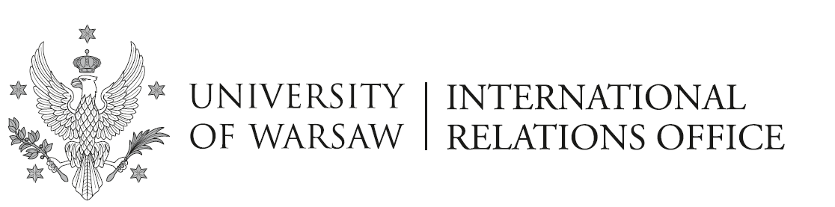

Announcement no 3/24/SMS/2024/2025
Erasmus - KA131/2024

Erasmus nominations to host universities completed

The International Relations Office (IRO) has completed the process of informing partner universities about the E r a s m u s students nominated for the academic year 2024/25. Partner (host) universities should now contact each student individually.

Students starting their mobility in the first semester who have not yet received any information from their host university are required to contact the host university (by email) to find out about the registration procedures and deadlines (the email address of the host university was sent to you in earlier correspondence from IRO).

Students nominated for the 2nd semester, who do not receive any information from their host university by the end of August, should contact their host university in September. Some universities only make it possible for IRO to nominate students for the second semester in Autumn and, consequently, will contact the students afterwards.

If your Erasmus mobility starts in the first semester and the host university informs you that your nomination has not reached them, please forward their message to erasmusbwz@uw.edu.pl.

Warsaw, 04.06.2024
Erasmus Section
International Relations Office

